**Hands-on Lab: Complete the Data Collection API Lab**

This **environment** is to do the **Peer Graded Assignment**.

In case you need to **download** the lab **notebook** **(.ipynb file**)

click [HERE](https://cf-courses-data.s3.us.cloud-object-storage.appdomain.cloud/IBM-DS0321EN-SkillsNetwork/labs/module_1_L2/jupyter-labs-spacex-data-collection-api.ipynb) to **download** the lab **notebook**.

<https://cf-courses-data.s3.us.cloud-object-storage.appdomain.cloud/IBM-DS0321EN-SkillsNetwork/labs/module_1_L2/jupyter-labs-spacex-data-collection-api.ipynb>

Once you **complete the lab**

* you can **download** the **notebook** as follows:
* Select the **notebook** which is displayed in the left **Navigation pane.**
* Right **click** on it and **click** on the **Download option**.
* Your **notebook** gets **downloaded**.

Later **upload** to **GitHub**

* by following the **instructions** in the reading [Getting Started with GitHub .](https://cf-courses-data.s3.us.cloud-object-storage.appdomain.cloud/IBMDeveloperSkillsNetwork-DS0105EN-SkillsNetwork/labs/Module2/GitHub1_Getting_Started.md.html?origin=www.coursera.org)

Further in the **MySubmission tab** of the assignment

* **paste** the **GitHub link** of the **notebook** in the **URL textbox**.

<https://www.coursera.org/learn/applied-data-science-capstone/peer/puYqJ/peer-review-submit-your-work-and-review-your-peers/submit>

[](https://skills.network/?utm_medium=Exinfluencer&utm_source=Exinfluencer&utm_content=000026UJ&utm_term=10006555&utm_id=NA-SkillsNetwork-Channel-SkillsNetworkCoursesIBMDS0321ENSkillsNetwork865-2022-01-01)

**SpaceX Falcon 9 first stage Landing Prediction**[**¶**](https://jupyterlab-3-labs-prod-jupyterlab-us-east-0.labs.cognitiveclass.ai/user/abiyselassie/lab/tree/labs/module_1_L2/jupyter-labs-spacex-data-collection-api.ipynb#SpaceX--Falcon-9-first-stage-Landing-Prediction)

**Lab 1: Collecting the data**

Estimated time needed: **45** minutes

<https://cf-courses-data.s3.us.cloud-object-storage.appdomain.cloud/IBM-DS0321EN-SkillsNetwork/labs/module_1_L2/jupyter-labs-spacex-data-collection-api.ipynb>

In this **capstone**, we will **predict**

* if the **Falcon 9 1st stage** will land **successfully**.

**SpaceX**

* advertises **Falcon** **9** **rocket launches** on its **website**,
* with a **cost** of **62** **million** **dollars**;

Other **providers**

* **cost** **upward** of **165** **million dollars** **each**, much of the **savings** is!
* b/c **SpaceX** can **reuse** the **1st** **stage**.

Therefore, if we can determine if the **1st** **stage** will **land**,

* we can determine the **cost** of a **launch**.

This **info** can be used

* if an **alternate** **company** wants to **bid against** **SpaceX** for a **rocket** **launch**.

In this lab,

* we will **collect** &
* make sure the data is in the **correct** **format** from an **API**.

An **example** of a **successful** **land launch** on the **Right**.



Several **examples** of an **unsuccessful** **landing** are shown below:



Most **unsuccessful** **landings** are **planned**.

* **Space X** performs a **controlled** **landing** in the **oceans**.

**Objectives**

In this **lab**, we will make a **get** **request** to the **SpaceX** **API**.

We will also do some basic **data** **wrangling** & **formatting**.

* **Request** to the **SpaceX** **API**
* **Clean** the **requested** **data**

**Import Libraries and Define Auxiliary Functions**

We will **import** the following **libraries** into the lab

*# Requests allows us to make HTTP requests which we will use to get data from an API*

**import** **requests**

*# Pandas is a software library written for the Python programming language for data manipulation and analysis.*

**import** **pandas** **as** **pd**

*# NumPy is a library for the Python programming language, adding support for large, multi-dimensional arrays and matrices, along with a large collection of high-level mathematical functions to operate on these arrays*

**import** **numpy** **as** **np**

*# Datetime is a library that allows us to represent dates*

**import** **datetime**

*​# Setting this option will print all columns of a dataframe*

**pd.set_option('display.max_columns', None)**

*# Setting this option will print all of the data in a feature*

***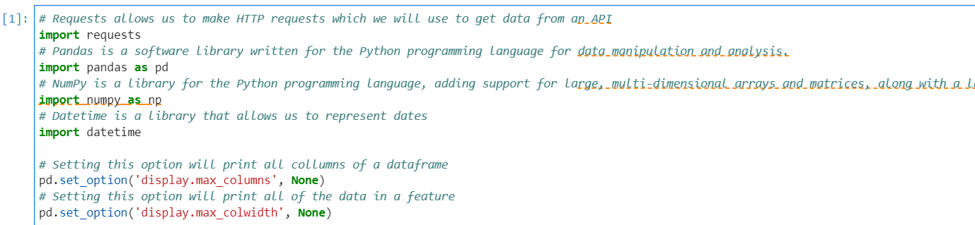*pd.set_option('display.max_colwidth', None)**

Below we will define a **series** of **helper** **functions**

* that will help us use the **API** to **extract** **info**
* using **identification** **nos**. in the **launch** **data**.

From the **rocket** **column**

* we would like to learn the **booster name.**

*# Takes the dataset and uses the rocket column to call the API and append the data to the list*

**def getBoosterVersion(data):**

**for x in data['rocket']:**

**if x:**

**response = requests.get("https://api.spacexdata.com/v4/rockets/"+str(x)).json()**

***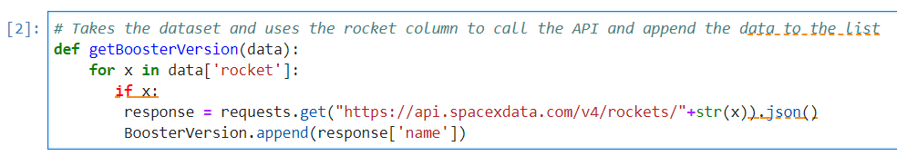* BoosterVersion.append(response['name'])**

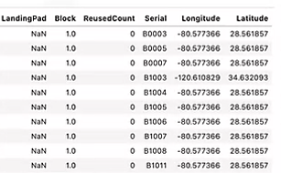

From the **launchpad**

* we would like to know
* the **name** of the **launch** **site** being used,
* the **longitude**, &
* the **latitude**.

*# Takes the dataset and uses the launchpad column to call the API and append the data to the list*

**def getLaunchSite(data):**

**for x in data['launchpad']:**

**if x:**

**response = requests.get("https://api.spacexdata.com/v4/launchpads/"+str(x)).json()**

**Longitude.append(response['longitude'])**

**Latitude.append(response['latitude'])**

**LaunchSite.append(response['name'])**

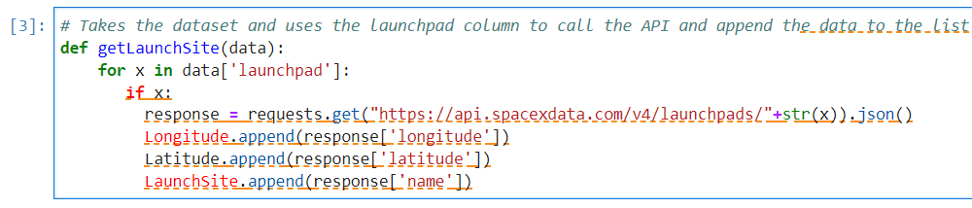

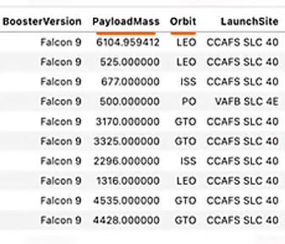From the **payload**

we would like to learn

* the **mass** of the **payload** &
* the **orbit** that it is going to.

*# Takes the dataset and uses the payloads column to call the API and append the data to the lists*

**def getPayloadData(data):**

**for load in data['payloads']:**

**if load:**

**response = requests.get("https://api.spacexdata.com/v4/payloads/"+load).json()**

**PayloadMass.append(response['mass_kg'])**

***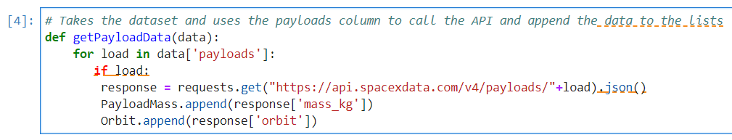* Orbit.append(response['orbit'])**

From **cores**

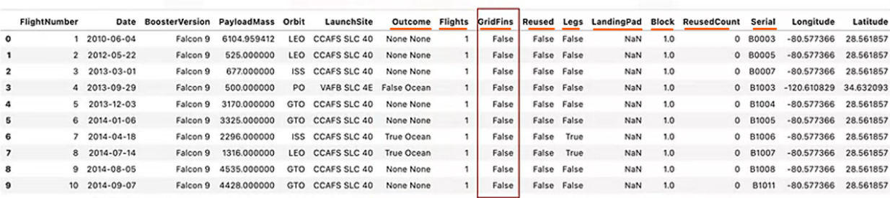we would like to learn

* the **outcome** of the **landing**,
* the **type** of the **landing**,
* **no.** of **flights** with that **core**,
* whether **gridfins** were **used**,
* whether the **core** is **reused**,
* whether **legs** were **used**,
* the **landing** **pad** **used**,
* the **block** of the **core**
* which is a **no**. used to separate **version** of **cores**,
* the **no**. of times this **specific** **core** has been **reused**, &
* the **serial** of the **core**.

*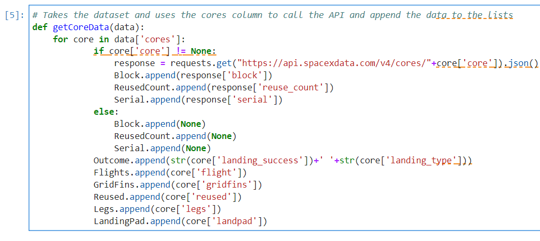# Takes the dataset and uses the cores column to call the API and append the data to the lists*

**def getCoreData(data):**

**for core in data['cores']:**

**if core['core'] != None:**

**response = requests.get("https://api.spacexdata.com/v4/cores/"+core['core']).json()**

**Block.append(response['block'])**

**ReusedCount.append(response['reuse_count'])**

**Serial.append(response['serial'])**

**else:**

**Block.append(None)**

**ReusedCount.append(None)**

**Serial.append(None)**

**Outcome.append(str(core['landing_success'])+' '+str(core['landing_type']))**

**Flights.append(core['flight'])**

**GridFins.append(core['gridfins'])**

**Reused.append(core['reused'])**

**Legs.append(core['legs'])**

**LandingPad.append(core['landpad'])**

Now let's start **requesting** **rocket launch** data from **SpaceX** **API**

* 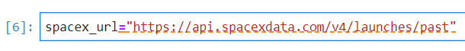with the following **URL**:

**spacex_url="https://api.spacexdata.com/v4/launches/past"**

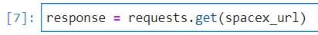

**response = requests.get(spacex_url)**

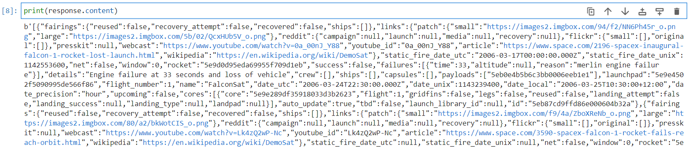Check the **content** of the **response**

**print(response.content)**

You should see the **response** contains

* **massive info** about **SpaceX launches**.

Next, let's try to discover some more **relevant info** for this **project**.

**Task 1: Request and parse the SpaceX launch data using the GET request**

To make the **requested** **JSON** **results** more **consistent**,

* we will use the following **static** **response** **object** for this **project**:

**static_json_url='https://cf-courses-data.s3.us.cloud-object-storage.appdomain.cloud/IBM-DS0321EN-SkillsNetwork/datasets/API_call_spacex_api.json'**

We should see that the **request** was successful with

* 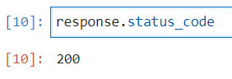the **200 status response code**

**response.status_code**

**200**

Now we **decode** the **response content** as a **Json**

* using **.json()**&

turn it into a **Pandas** **dataframe**

* using .**json_normalize()**

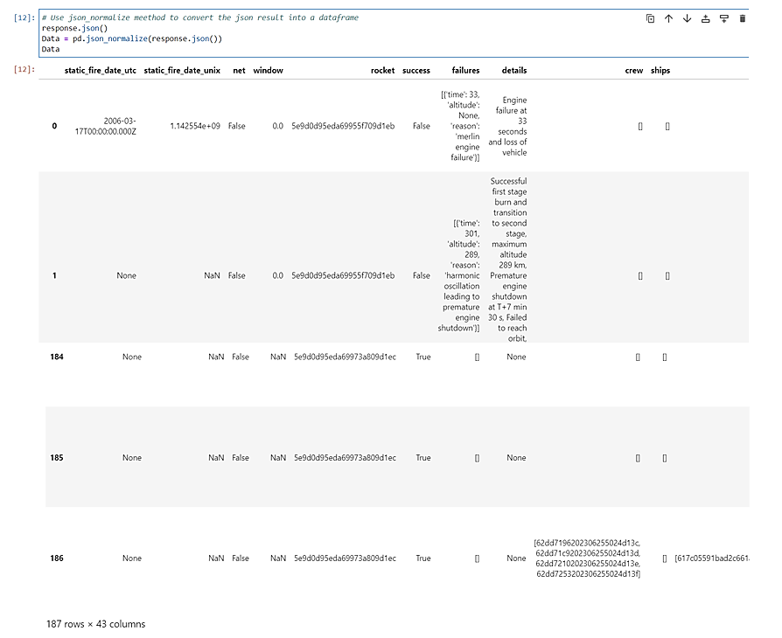*# Use json_normalize method to convert the json result into a dataframe*

**response.json()**

**Data = pd.json_normalize(response.json())**

**Data**

​

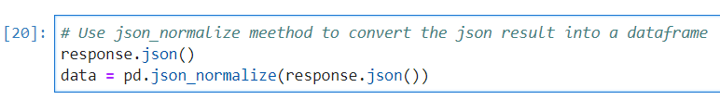

Using the **dataframe** **data**

* 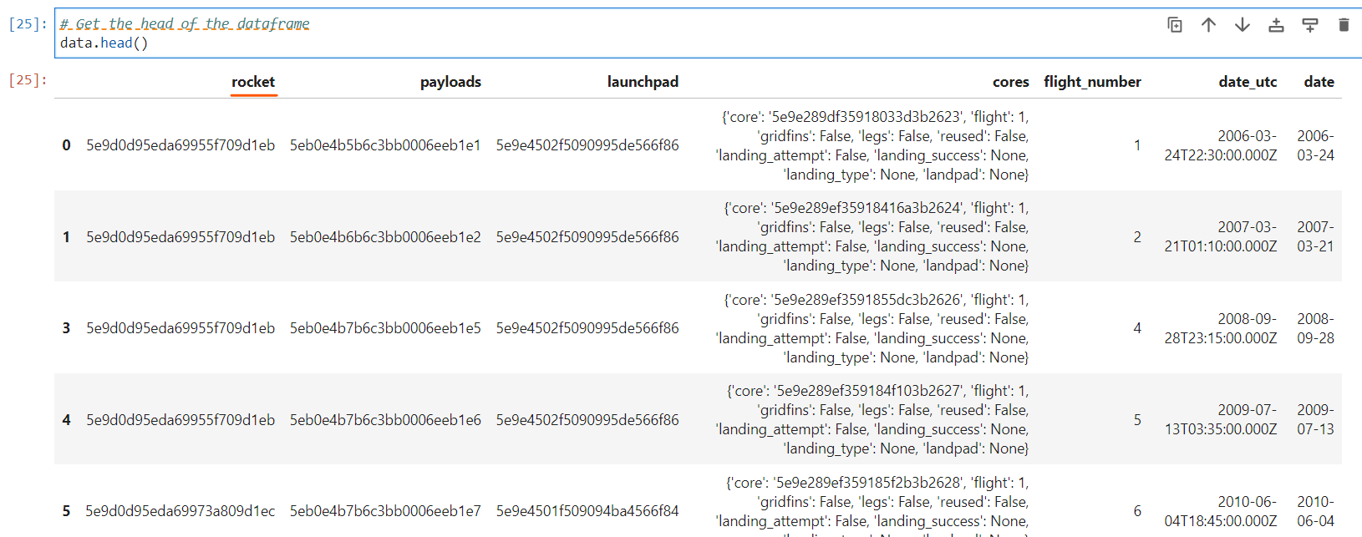**print** the **1st** **5** **rows**

*# Get the head of the dataframe*

​ **data.head()**

We will notice that a lot of the **data** are **IDs**.

E.g. The **rocket column** has **no** **info** about the **rocket**

* just an **identification** **number**.

We will now use the **API** again to get **info** about the **launches**

* using the **IDs** given for each **launch**.

Specifically, we will be using **columns**

* **rocket, payloads, launchpad, cores**.

*# Lets take a subset of our dataframe keeping only the features we want and the flight number, and date_utc.*

**data = data[['rocket', 'payloads', 'launchpad', 'cores', 'flight_number', 'date_utc']]**

*​# We will remove rows with multiple cores because those are falcon rockets with 2 extra rocket boosters and rows that have multiple payloads in a single rocket.*

**data = data[data['cores'].map(len)==1]**

**data = data[data['payloads'].map(len)==1]​**

*# Since payloads and cores are lists of size 1 we will also extract the single value in the list and replace the feature.*

**data['cores'] = data['cores'].map(lambda x : x[0])**

**data['payloads'] = data['payloads'].map(lambda x : x[0])​**

*# We also want to convert the date_utc to a datetime datatype and then extracting the date leaving the time*

**data['date'] = pd.to_datetime(data['date_utc']).dt.date​**

*# Using the date we will restrict the dates of the launches*

**data = data[data['date'] <= datetime.date(2020, 11, 13)]**

From **cores** we would like to learn

* the **outcome** of the **landing**,
* the **type** of the **landing**,
* **no.** of **flights** with that **core**,
* whether **gridfins** were used,
* whether the **core** is **reused**,
* whether **legs** were used,
* the **landing** **pad** used,
* the **block** of the **core**
* which is a **no**. used to separate **version** of **cores**,
* the **no.** of **times** this specific **core** has been **reused**,
* the **serial** of the **core**.

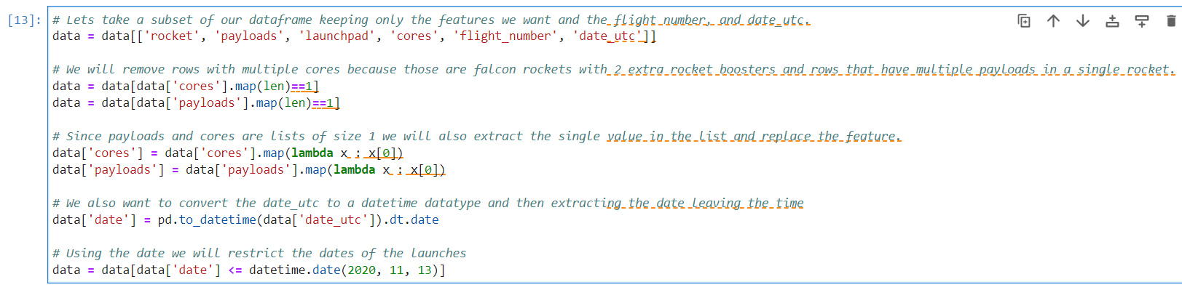

From the **rocket** we would like to learn

* the **booster** **name**

From the **payload** we would like to learn

* the **mass** of the **payload** &
* the **orbit** that it is going to

From the **launchpad** we would like to know

* the **name** of the **launch** **site** being used,
* the **longitude**, &
* the **latitude**.

The data from these **requests**

* will be **stored** in **lists** &
* will be used to create a **new** **dataframe**.

*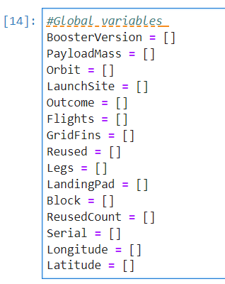#Global variables*

**BoosterVersion = []**

**PayloadMass = []**

**Orbit = []**

**LaunchSite = []**

**Outcome = []**

**Flights = []**

**GridFins = []**

**Reused = []**

**Legs = []**

**LandingPad = []**

**Block = []**

**ReusedCount = []**

**Serial = []**

**Longitude = []**

**Latitude = []**

These **functions**

* will apply the **outputs** **globally** to the above **variables**.

Let's take a look at **BoosterVersion** **variable**.

Before we apply **getBoosterVersion**

* the **list** is **empty**:

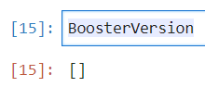

**BoosterVersion**

**[]**

Now, let's apply  **getBoosterVersion** **function** method

* 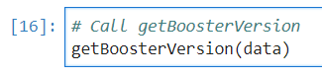to **get** the **booster version**

**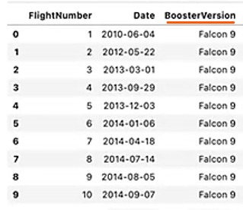***# Call getBoosterVersion*

**getBoosterVersion(data)**

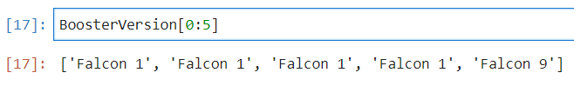The **list** has now been **updated.**

**BoosterVersion[0:5]**

**['Falcon 1', 'Falcon 1', 'Falcon 1', 'Falcon 1', 'Falcon 9']**

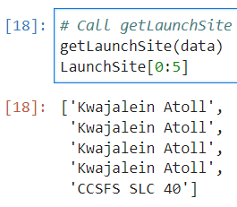We can apply the **rest** of the **functions** here:

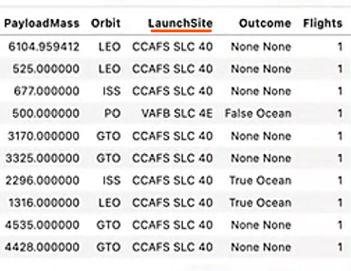*# Call getLaunchSite*

**getLaunchSite(data)**

**LaunchSite[0:5]**

**['Kwajalein Atoll',**

**'Kwajalein Atoll',**

**'Kwajalein Atoll',**

**'Kwajalein Atoll',**

**'CCSFS SLC 40']**

**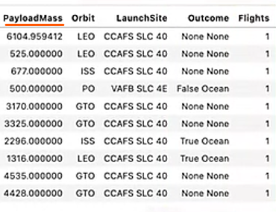***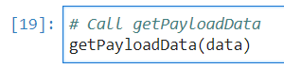 # Call getPayloadData*

**getPayloadData(data)**

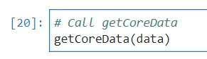

*# Call getCoreData*

**getCoreData(data**)

Finally let’s construct our **dataset**

* using the data we have obtained.

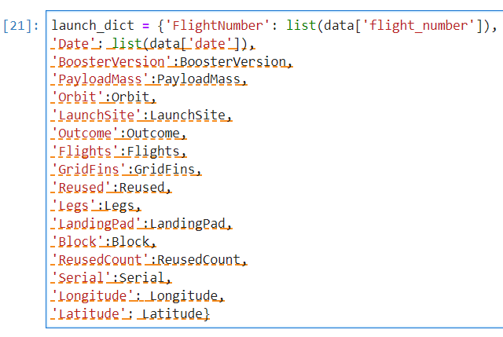We combine the **columns** into a **dictionary**.

**launch_dict = {'FlightNumber': list(data['flight_number']),**

**'Date': list(data['date']),**

**'BoosterVersion':BoosterVersion,**

**'PayloadMass':PayloadMass,**

**'Orbit':Orbit,**

**'LaunchSite':LaunchSite,**

**'Outcome':Outcome,**

**'Flights':Flights,**

**'GridFins':GridFins,**

**'Reused':Reused,**

**'Legs':Legs,**

**'LandingPad':LandingPad,**

**'Block':Block,**

**'ReusedCount':ReusedCount,**

**'Serial':Serial,**

**'Longitude': Longitude,**

**'Latitude': Latitude}**

​

Then, we need to create a **Pandas** **data frame**

* from the **dictionary** **launch_dict**.

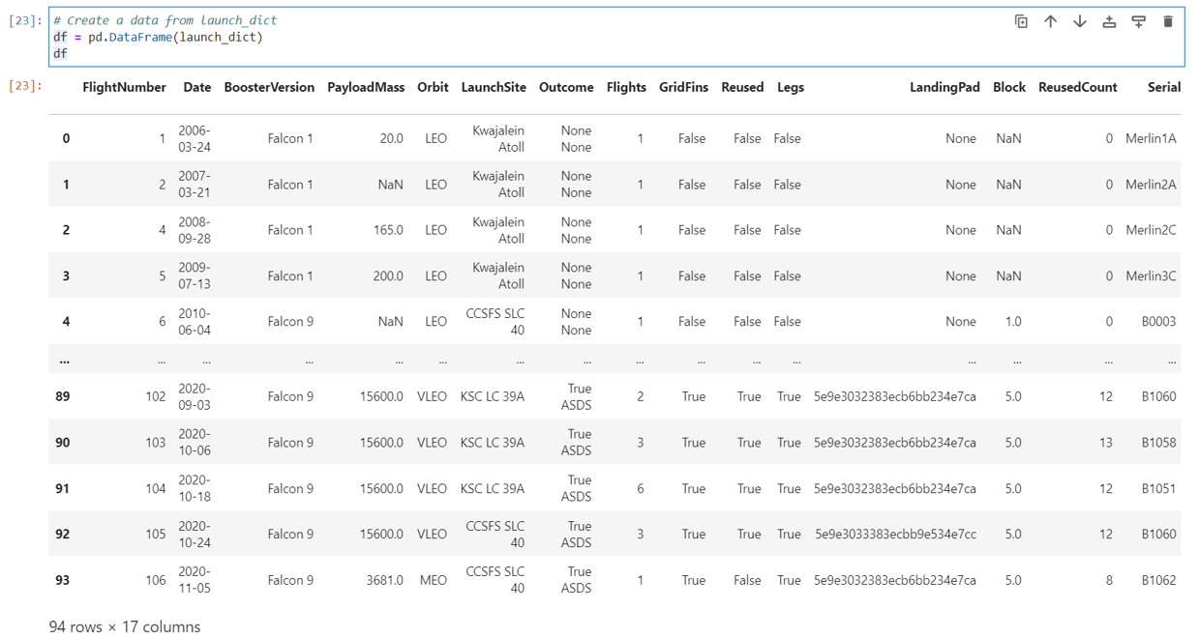*# Create a data from launch_dict*

**df.DataFrame(launch_dict)**

**df**

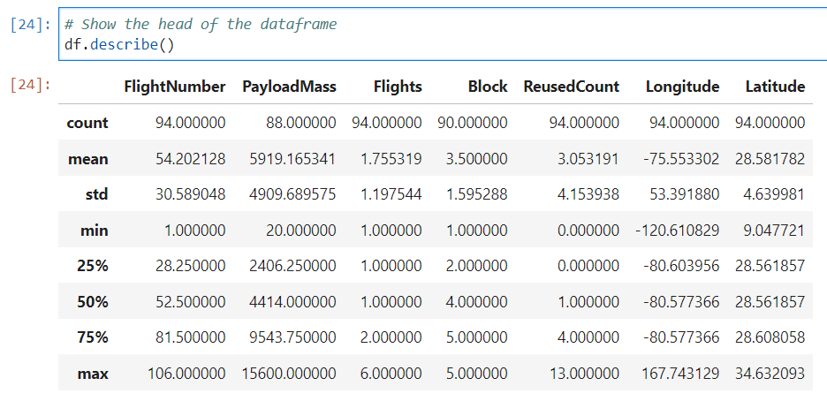Show the **summary** of the **dataframe**

**df.describe()**

**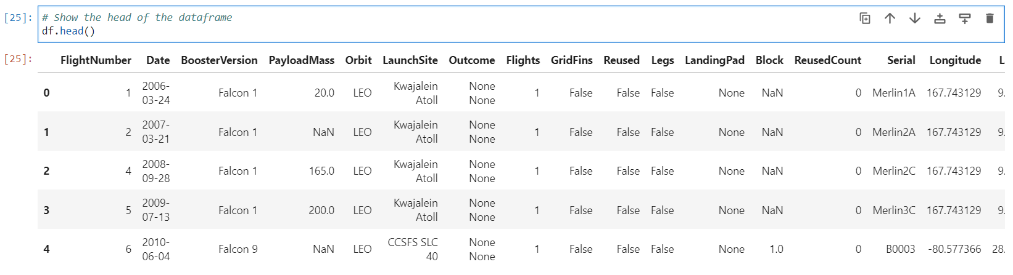***# Show the head of the dataframe*

**df.head()**

**Task 2: Filter the dataframe to only include Falcon 9 launches**

Finally, we will **remove** the **Falcon 1** **launches**

* keeping only the **Falcon 9** **launches**.

**Filter** the data **dataframe**

* using the **BoosterVersion** **column**
* to only **keep** the **Falcon 9** **launches**.

**Save** the **filtered** **data** to a **new** **dataframe**

* called **data_falcon9.**

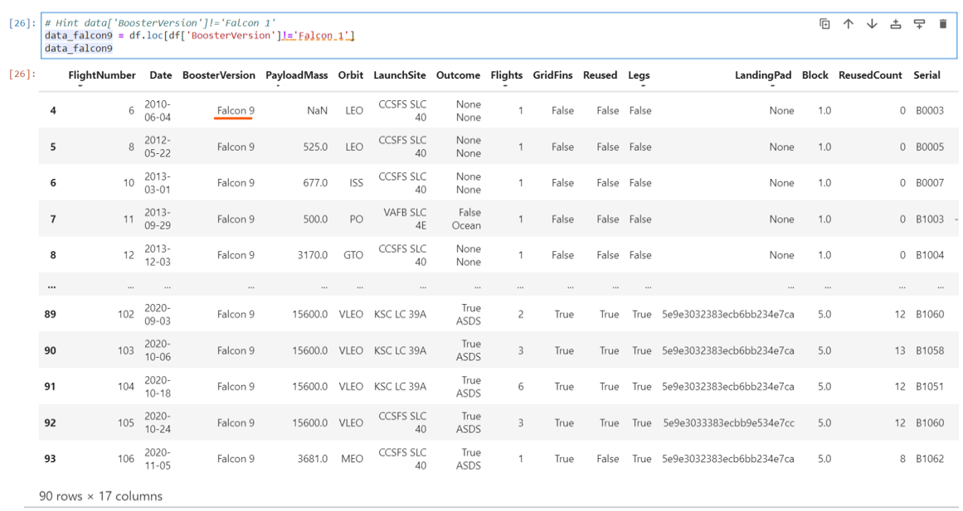*# Hint data['BoosterVersion']!='Falcon 1'*

**data_falcon9 = df.loc[df['BoosterVersion']!='Falcon 1']**

**data_falcon9**

​

Now that we have **removed** some **values**

* we should **reset** the **Flight Number** **column**

**data_falcon9.loc[:,'FlightNumber'] = list(range(1, data_falcon9.shape[0]+1))**

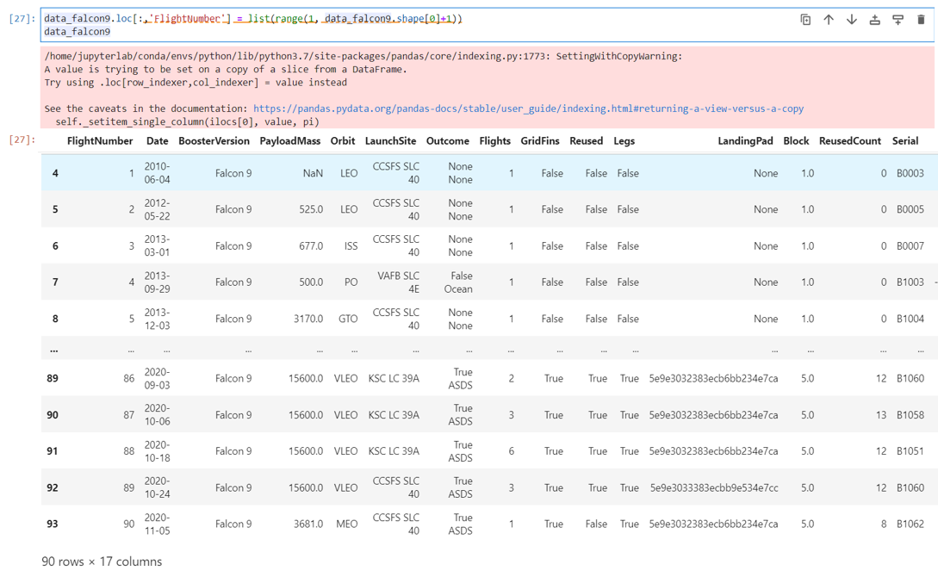**data_falcon9**

**Data Wrangling**

We can see that some of the **rows** below

* 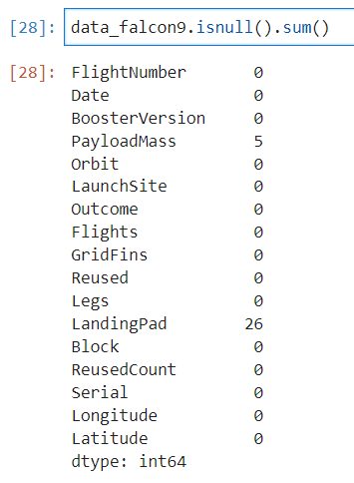 are **missing** **values** in our **dataset**.

**data_falcon9.isnull().sum()**

Before we can continue

* we must deal with these **missing** **values**.

The **LandingPad column**

* will retain **None** **values** to represent
* when **landing pads** were **not** used.

**Task 3: Dealing with Missing Values**

**Calculate** below the **mean** for the **PayloadMass**

* using the .**mean**().

Then use the **mean** & the **.replace()** **function**

* to **replace** **np.nan values** in the data
* 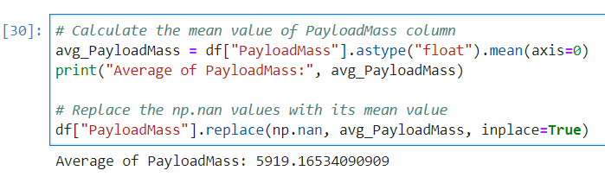with the **mean** we **calculated**.

​ *# Calculate the* mean value *of* PayloadMass column

**avg_****PayloadMass= df["PayloadMass"].astype("float").mean(axis=0)**

**print("Average of** **PayloadMass:", avg_****PayloadMass)**

*# Replace the np.nan values with its mean value*

**df["PayloadMass "].replace(np.nan, avg_ PayloadMass, inplace=True)**

**Average of PayloadMass: 5919.16534090909**

We should see the **no**. of **missing** **values** of the **PayLoadMass** change to **0**.

Now we should have **no** **missing** **values** in our **dataset**

* 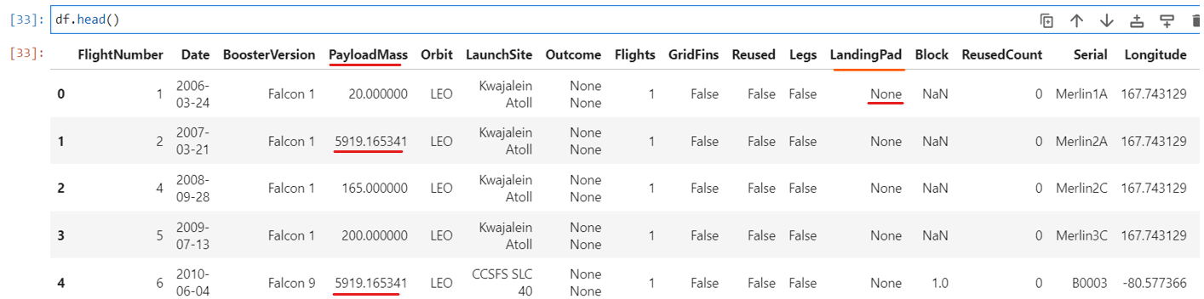**except for** in **LandingPad**.

**df.head()**

**Compare** it with previous **output** below.

We can now **export** it to a **CSV** for the next section,

but to make the answers **consistent**, in the next lab we will provide data in a **pre-selected** **date range.**

* **data_falcon9.to_csv('dataset_part_1.csv', index=False)**

**GitHub link**

<https://github.com/abiyselassie22/testpro/blob/main/jupyter-labs-spacex-data-collection-api%20(1).ipynb>

https://github.com/abiyselassie22/testpro/blob/master/jupyter-labs-spacex-data-collection-api%20(1).ipynb

https://github.com/abiyselassie22/caprepo/blob/master/jupyter-labs-spacex-data-collection-api%20(1).ipynb

**Authors**

[Joseph Santarcangelo](https://www.linkedin.com/in/joseph-s-50398b136/?utm_medium=Exinfluencer&utm_source=Exinfluencer&utm_content=000026UJ&utm_term=10006555&utm_id=NA-SkillsNetwork-Channel-SkillsNetworkCoursesIBMDS0321ENSkillsNetwork865-2022-01-01) has a PhD in Electrical Engineering, his research focused on using machine learning, signal processing, and computer vision to determine how videos impact human cognition. Joseph has been working for IBM since he completed his PhD.

**How to Complete the Data Collection API Lab with Watson Studio**

You will need to **import** and complete the following **Jupyter notebook** in **IBM Watson Studio**:

**Right-click the following link, and copy its URL then import it to Watson Studio:**

[Data Collection API](https://cf-courses-data.s3.us.cloud-object-storage.appdomain.cloud/IBM-DS0321EN-SkillsNetwork/labs/module_1_L2/jupyter-labs-spacex-data-collection-api.ipynb)

<https://cf-courses-data.s3.us.cloud-object-storage.appdomain.cloud/IBM-DS0321EN-SkillsNetwork/labs/module_1_L2/jupyter-labs-spacex-data-collection-api.ipynb>

If you need help with **importing** **notebook** to **Watson Studio**, refer to this lab:

[Import a Notebook into Watson Studio](https://cf-courses-data.s3.us.cloud-object-storage.appdomain.cloud/IBM-DS0321EN-SkillsNetwork/labs/AddingNotebook_toWatson.md.html)

<https://cf-courses-data.s3.us.cloud-object-storage.appdomain.cloud/IBM-DS0321EN-SkillsNetwork/labs/AddingNotebook_toWatson.md.html>

If you see **Failed** to **Load** **Notebook** **error** **message**,

* you may go back and check your **Notebook** list
* to see if it is a **false alarm** that your **notebook** could be **imported** already.

**Checkpoints Data Collection**

